Lesson 3 – HTML Text Elements

1. Headings:

- <https://www.w3schools.com/html/html_headings.asp> (+++ [excercises](https://www.w3schools.com/html/exercise.asp?filename=exercise_headings1))

2. Paragraphs:

- <https://www.w3schools.com/html/html_paragraphs.asp> (+++ [excercises](https://www.w3schools.com/html/exercise.asp?filename=exercise_paragraphs1))

3. Semantic formatting:

- <https://www.w3schools.com/html/html_formatting.asp> (+++ [excercises](https://www.w3schools.com/html/exercise.asp?filename=exercise_formatting1))

Task – Publishing your HTML webpage online:

* Make your webpage (from the previous lesson) available through the NAS **webserver**.
* Copy both files (the **html document** and the corresponding **image**) to **www folder** in your home directory:

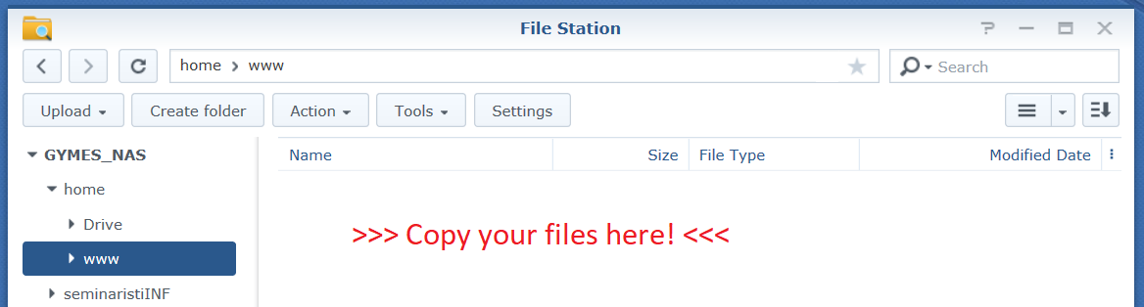

* Rename the html document to **index.html**
* Access the page via these links (don’t forget to replace **NameSurname** with your **login**):
  + unsecured HTTP protocol:
    - [http://gymeske.synology.me:1080/~**NameSurname**/index.html](http://gymeske.synology.me:1080/~NameSurname/index.html)
  + secured HTTPS protocol:
    - [https://gymeske.synology.me:1443/~**NameSurname**/index.html](https://gymeske.synology.me:1443/~NameSurname/index.html)
* Try to access the page from your classmate’s computer (without being logged in to the NAS).
* Try to access the page from home 😊